Threads of Memories
The story of 150 years of the Anglican Parish of St Stephen & St Mary, Mount Waverley

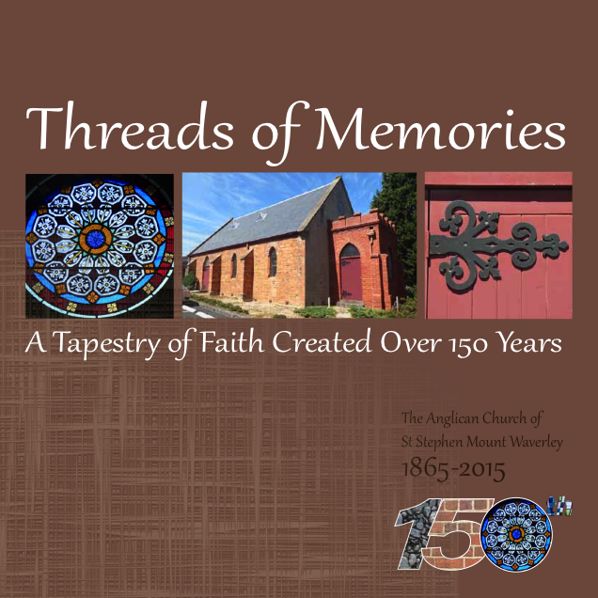
This year is the 150th anniversary of the construction of the original church of St Stephen at 383 High Street Road, Mount Waverley.
It is one of the oldest buildings in the area and the oldest continuing church in the City of Waverley/Monash.
To commemorate this important landmark, the book, ‘Threads of Memories’ will be launched at the official 150th anniversary celebrations on 26 July 2015.
The parish warmly invites you to celebrate 150 years of Christian worship and mission with us during this special year.
Pre-order your copy/ies now for collection on 26 July.

Order form: ‘Threads of Memories’
All orders will be delivered to you at the official launch on 26 July 2015 unless you request that it is posted to you (postal charges apply).
First name:___________________________________ Last name: __________________________________________________
Phone no._____________________________________ Email: _______________________________________________________
☐ I wish to purchase ____ copy/ies of ‘Threads of Memories’ at $25 per copy
☐ I wish to have my copy/ies posted to me at $5 per copy, posted to:
Street/No.______________________________________________________Suburb_____________________________
State ____________________ Postcode________________
Payment Details
Total amount payable: $____________________ I wish to pay by:
☐ Cheque: payable to ‘St Stephen’s & St Mary’s Anglican Parish’; post to 150th Committee, St Stephen’s & St Mary’s Anglican Parish, 383 High Street Road, Mount Waverley, VIC 3149
☐ EFT Payment direct to bank: Account name: Parish of St Stephen & St Mary Mount Waverley General Account; BSB: 033-038; Account No: 21 1656, Note: please include your name and ‘150th book’ as your reference.
Contact the 150 Anniversary Committee on 9807 3168 or email 150@stephenandmary.org.au for assistance.

